Reg. No. CODE: SPH2

PH. D COURSEWORK END SEM EXAMINATION, MAY 2023

SUBJECT: FORENSIC SCIENCE

SPECIALIZATION PAPER 2 - FINGERPRINT AND IMPRESSION ANALYSIS

Time: 03 hours Maximum Marks: 50

Name: Gayathri V

Instructions:
- Section A Compulsory
- Answer any four from Section B
- Each question carries 10 Marks

SECTION A

Answer the following question: (10 Marks)

- Explain the histology of friction skin ridge.

SECTION B

Answer any four from the following question: (Each carrying 10 Marks)

2. Describe the powder suspension technique and its advantages over conventional powders.

3. Mention the composition of various powders used in the development of latent fingerprints.

4. Explain in detail the significance, identification, development, and comparison of human foot impressions.

5. Discuss the importance, identification, and comparison of palm prints.

6. 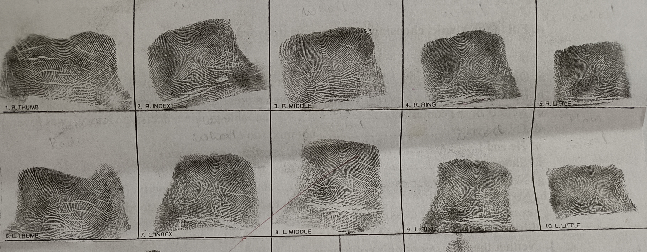

Classify the given chart of fingerprint based on Henry’s ten-digit classification system and explain it.

7. In a road traffic accident case, footwear and tire impressions were found. Discuss the importance of these evidences and explain the collection and preservation of them.

********

